**Write summary for bugs on the screenshots**

1) The “Exclusives” button in the main menu contains a typo;

2)The name of the button “Gift finder” isn’t aligned on the header on the general page;

3)The rating bar is absent under product ”1989 Batmobile” on the general page;

4)The button “Shop now” isn’t corresponds to design of the site on the general page;

5)The name of the button “Add to Cart” isn’t correct;

6)Not all text is displayed on the footer on the general page.

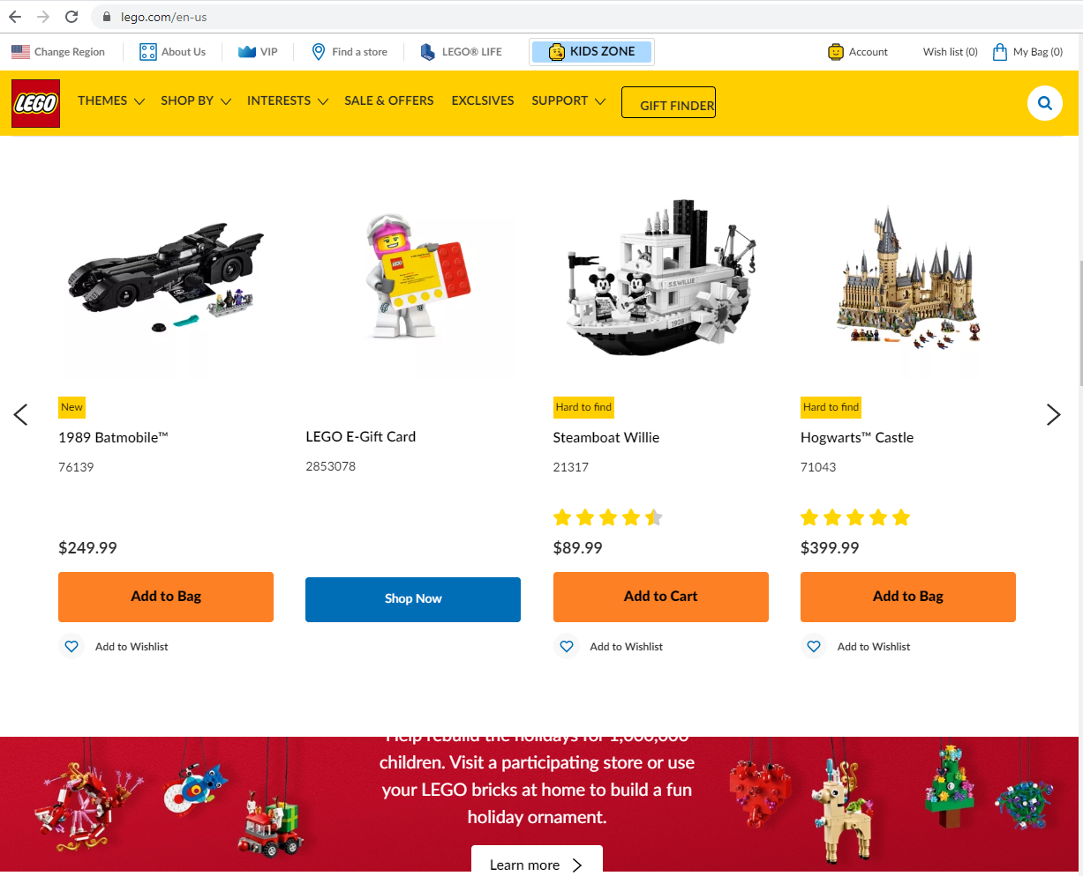

2)

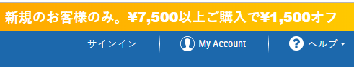

1)The icon near “サインイン” is absent on the header;

2)The button “My Account” is written on English on the header;

3)The name of the button is absent on the header;

3)

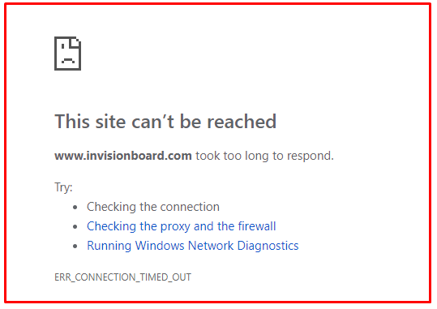

1) the site isn’t available because of load is exceeded;

2) Error message has red frame on the screen

4)

1) The phone number isn’t active on the header on the “скачать” page.

2) Buttons “скачать фото.Коллекция 10,11,12” have difference size with buttons “скачать фото.Коллекция 1-9” on the “скачать” page.

3) the button “home” is written on English

4) The indent is absent between “Каталог фото для скачивания” and buttons “скачать фото. Коллекция 1”

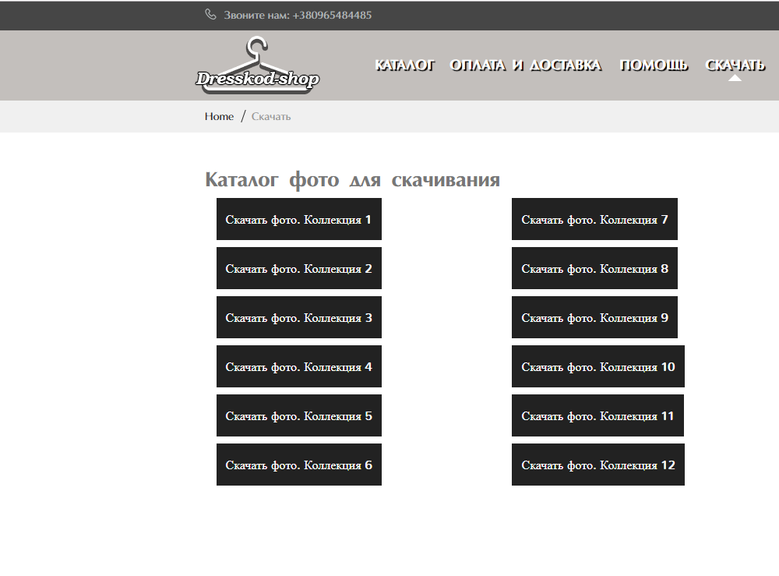

5)

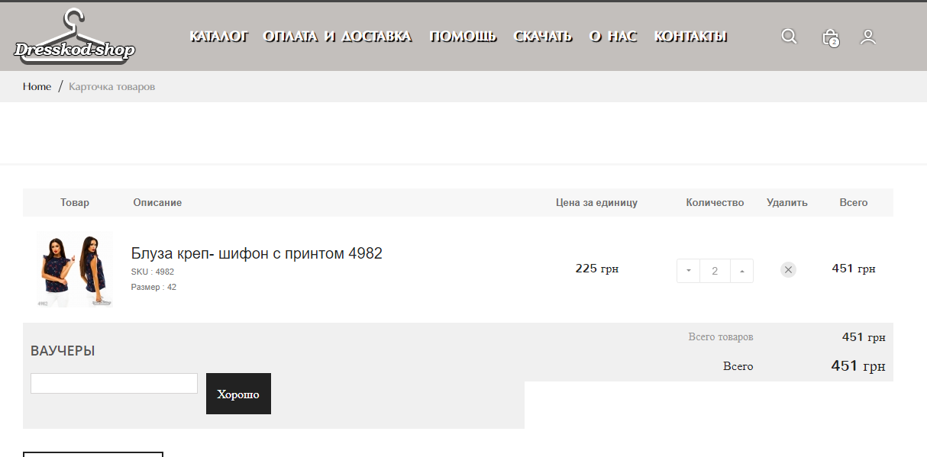

1. The price of products counts incorrect on the page “карточка товаров”
2. Duplicate SKU is displayed in the name of the product and in the description on the page “карточка товаров”
3. The SKU of the product is displayed twice ( in the name and in the description) on the page “карточка товаров”
4. The raw “всего товаров” has isn’t correct font in the column “Количество” on the page “карточка товаров”;
5. In the raw “всего товаров” displayed sum of product, not quantity of products on the page “карточка товаров”;

Quantity of the products isn’t displayed in the raw “всего товаров” on the page “карточка товаров”;

1. The button “хорошо” too large according o “ваучеры” field